DATA INTEGRATION SCRIPT FOR GOOGLE ANALYTICS

BY DYNAMICS 365 COMMERCE

Contents

Overview 2

Set up a Tag Manager account and generate a script 2

Set up fragments in Commerce site builder 2

1. Create the Tag Manager script fragment 3

2 Create the Google Analytics script fragment to handle events 4

Add inline script fragments to the site templates 4

Test the Tag Manager and Commerce integration 5

Fix tags 6

Troubleshoot integration issues 6

# 

## Overview

Google Tag Manager is a free tool that allows for easy management and deployment of snippets of code or tracking pixels, known as tags, on a website. It also enables data to be shared from a website to the analytics site.

You can use Tag Manager with your Microsoft Dynamics 365 Commerce e-commerce site to collect usage data that can be analyzed through Google Analytics. This document explains the set up process in Tag Manager and Commerce site builder.

## Set up a Tag Manager account and generate a script

To set up the integration between Tag Manager and Commerce, you must first configure Tag Manager and copy your Tag Manager script. Follow the steps below to get started:

1. Go to the [Tag Manager website](https://tagmanager.google.com/#/home), select **Create Account**, and complete the relevant fields in the **Account Setup** section.
2. In the **Container Setup** section, in the **Container name** field, enter a descriptive identifier for the website that you will collect data from. In the **Target platform** field, select **Web**.
3. Select **Create**.
4. Accept the Terms of Service Agreement.
5. A unique Tag Manager ID is assigned to the account. For the next section, you will need the Tag Manager script for your account. To retrieve your script, select the ID in the upper-right corner of the Tag Manager page, as highlighted in Figure 1.
6. Copy the script that appears in the **Paste this code as high in the <head> of the page as possible** section.

Important: When you copy the script, start at (function(w,d,s,l,i), and stop after GTM-<account_ID>’. Make sure that ;</script> <!-- End Google Tag Manager --> isn’t included.



**Figure 1: Tag Manager ID**

## Set up fragments in Commerce site builder

Next, in Commerce site builder, you must set up the building blocks that will be used on your website to capture events and share data with Tag Manager. First, you will need to create a fragment using your Tag Manager account script. You will then create a fragment using an all-events script to capture events on your webpages.

### Create the Tag Manager script fragment

* 1. Open Commerce site builder.
  2. Open the site that you want to add the Tag Manager functionality to.
  3. In the left pane, select **Fragments**, and then select **New**.
  4. In the **New fragment** dialog box, in the **Search Modules** field, enter **inline**.
  5. In the list of search results, select **Inline script**. Then, in the **fragment name** field, enter a name for the script. For example, enter **GTM Script**.

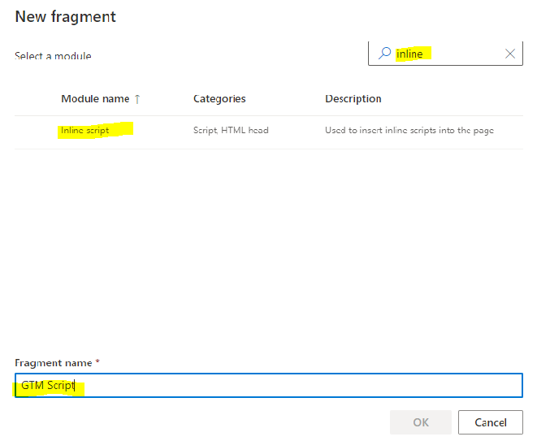

* 1. Select **OK**.
  2. On the **Fragments** page,select **the Default inline script** module.
  3. In the **Default inline script** pane on the right, in the **Inline script** field, paste the Tag Manager script that you copied in step 6 in the “Set up a Tag Manager account and generate a script” section.
  4. Select **Finish editing**.
  5. In the **Finish editing fragment** dialog box, in the **Comments** field, enter any notes that you want to enter for the script fragment.
  6. Select **OK**.
  7. Select **Publish**.

### Create the Google Analytics script fragment to handle events

* 1. Double click on the embedded .txt file and copy the contents of the script. 
  2. Open Commerce site builder.
  3. Open the site that you want to add the Tag Manager functionality to.
  4. In the left pane, select **Fragments**, and then select **New**.
  5. In the **New fragment** dialog box, in the **Search Modules** field, enter **inline**.
  6. In the list of search results, select **Inline script**. Then, in the **Page name** field enter a name for the script. For example, enter **Google Analytics Events**.
  7. Select **OK**.
  8. On the **Fragments** page,select **the Default inline script** module.
  9. In the **Default inline script** pane on the right, in the **Inline script** field, paste all events script which you copied in step 2.1.
  10. Select **Finish editing**.
  11. In the **Finish editing fragment** dialog box, in the **Comments** field, enter any notes that you want to enter for the script fragment.
  12. Select **OK**.
  13. Select **Publish**.

## Add inline script fragments to the site templates

Now that you have an inline script fragment with the Google Tag Manager script added, you will include this on all of the e-Commerce pages where you want to track events and capture data on. Each page derives from a template, so you can easily add this fragment to the template of the respective pages.

You can add the script fragments to as many or as few pages as you want. However, they should be added only to category pages, product details pages, checkout pages, purchase confirmation pages, and order confirmation pages, because those types of pages are the only types that events can be captured on.

1. In Commerce site builder, in the left pane, select **Templates**.
2. In the list of templates for your site, select the name of the template that is used for the pages that you want to track events on.
3. In the upper-right corner, select **Edit**.
4. In the tree, select **HTML head**, select the ellipsis (**…**), and then select **Add Fragment**.
5. In the **Select Fragment** dialog box, select the fragment that you created in step 1 in the “Set up fragments in Commerce site builder” section, and then select **OK**.
6. Go back to **HTML head**, select the ellipsis (**…**), and then select **Add Fragment**.
7. In the **Select Fragment** dialog box, select the fragment that you created in step 2 in the “Set up fragments in Commerce site builder” section.
8. Select **Finish editing** to check in the template.
9. Select **Publish** to publish the template.
10. Repeat steps 1 through 9 for all templates that you want to track events on and capture data for.

### Test the Tag Manager and Commerce integration

After you publish your site that includes the Tag Manager integration, you should test to make sure that tags were set up correctly on your site, and that event data is being captured.

1. Test the integration from your live e-commerce site.
   1. Install [Tag Assistant (by Google)](https://chrome.google.com/webstore/detail/tag-assistant-by-google/kejbdjndbnbjgmefkgdddjlbokphdefk) from the Chrome Web Store.
   2. On a new browser tab or in a new browser window, go to your live e-commerce website.
   3. Select the Tag Assistant extension in the browser, and then select **Enable**.
   4. On your e-commerce site, perform some actions that you expect to be tracked via the integration. For example, select a product, and add it to the cart.
   5. In the Tag Assistant extension, select the **Data Layer** tab. Events should appear on the **Data Layer** tab in real time as you perform actions on the website.

Make sure that the actions that you expect to be captured are being captured.

1. Test the integration in debug mode.

If you’re the Tag Manager account owner, you can test in debug mode if you prefer.

* 1. Go back to the [Tag Manager website](https://tagmanager.google.com/#/home). Select the URL for the account that you set up in the “Set up a Tag Manager account and generate a script” section.
  2. In the upper-right corner of the Tag Manager page, select **Preview**.
  3. On a new browser tab or in a new browser window, go to your live e-commerce website, and refresh the page.
  4. Go back to the Tag Manager page, and make sure that debug mode is turned on and working.
  5. You can now do your testing in debug mode on the Tag Manager page.

### Fix tags

When you test the integration, you might discover that some actions that can be performed on your website, and that you expect to be captured by Tag Manager, aren’t being captured. In most cases, this issue occurs because the CSS class Name is incorrect in the script. Follow these steps to fix the tags that are required to capture the events.

1. Find the CSS class Name for the event that you want to capture.
   1. Go to the relevant e-commerce page and select **F12** to open the developer tools.
   2. Select **Ctrl**+**Shift**+**C**, and then select the UI for the event that you want to capture on the webpage. The CSS class Name should appear on the **Elements** tab in the developer tools.
2. Go back to the [all-events script page](https://github.com/microsoft/msdyn365-ecommerce-customer-onboarding/blob/customercustomizations/marketplace-connectors/GTM/ga-allevents-generic-new-2.0.txt).
3. Find the CSS class Name on the page.
4. If the variable on the all-events script page doesn’t match the CSS class Name, change the variable on the all-events script page so that it matches the CSS class Name. Then copy the modified script.
5. In Commerce site builder, go to **Fragments**, select the name of the fragment that uses the all-events script, and then select **Edit** in the upper-right corner. Select **Default inline script**, and then, in the **Inline script** field in the right pane, paste the modified script. Then select **Finish editing**.



Figure 3: The variable matches in both places.

### 

### Troubleshoot integration issues

**Issue:** Events aren’t being captured in the Tag Manager data layer, but there is no error message in the developer tools console.

**Try this:**

1. In Commerce site builder, select **Site Settings** in the lower-left corner of the page.
2. Select **Extensions**.
3. On the **Content security policy** tab,select **Disable content security policy**.
4. Under **child-src**,select **Add**.
5. In the field, enter the URL for the Tag Manager site.